**Phase 2: Org Setup & Configuration**

**1. Salesforce Editions**

1. Go to [Salesforce Developer Signup](https://developer.salesforce.com/signup) and create a **Developer Edition org**.
2. Confirm email, set a password, and **sign in**.
3. Switch to **Lightning Experience** (if in Classic):

Click avatar → **Switch to Lightning Experience**.

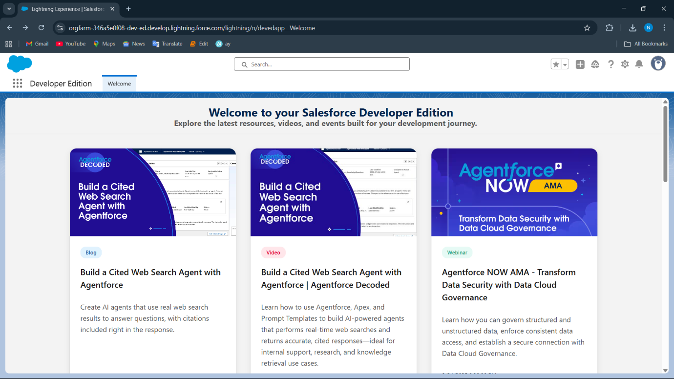

**2. Company Profile Setup**

1. Go to **Setup (⚙️ → Setup)**.
2. Quick Find → **Company Information** → **Edit**.
3. Fill details:

* **Company Name:** Sports Retail Management Pvt Ltd
* **Primary Contact:** Your Name
* **Default Time Zone:** (GMT+05:30) India Standard Time (Asia/Colombo)
* **Default Locale:** Malayalam (India)
* **Default Language:** English
* **Default Currency:** INR – Indian Rupee
* **Fiscal Year:** Standard Fiscal Year (Jan–Dec)

1. **Save** changes.

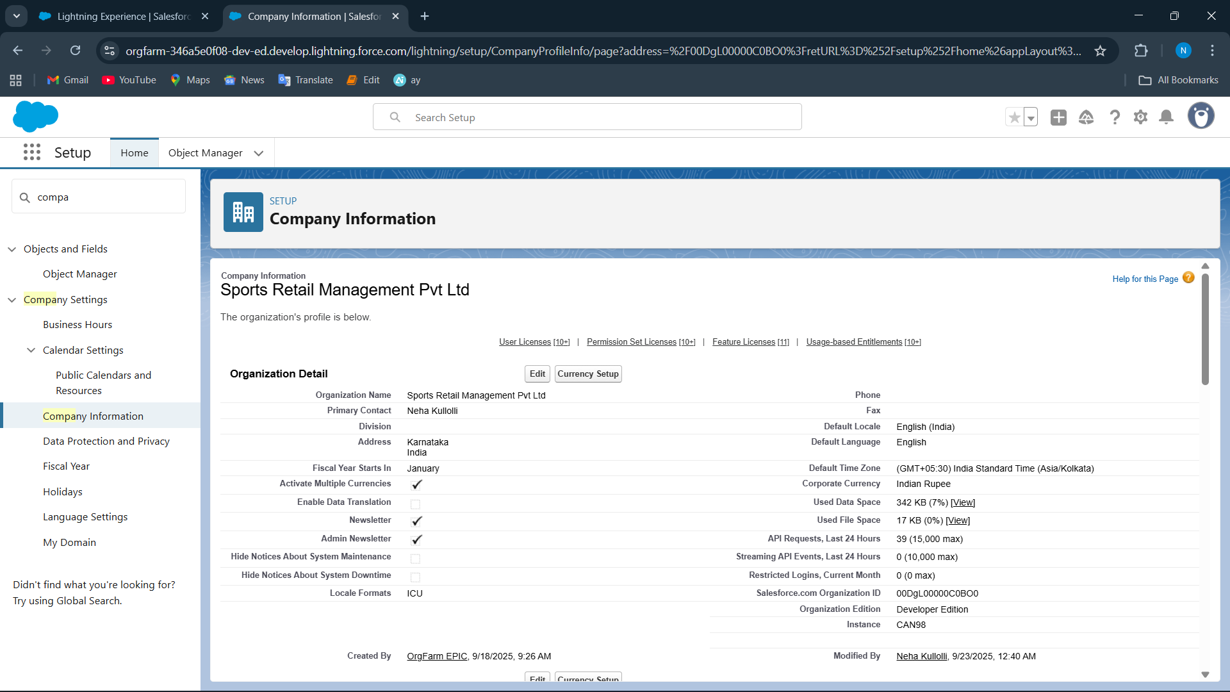

**3. Business Hours & Holidays**

1. Go to **Setup → Company Settings → Business Hours**.
2. Click **New Business Hours**.

* **Label:** Sports Shop Hours
* **Time Zone:** (GMT+05:30) India Standard Time (Asia/Colombo)
* **Default:** ✔ (make it default)
* Set hours:
  + Monday → 09:00am to 6:00pm
  + Saturday & Sunday → Unchecked (closed)
* Save.

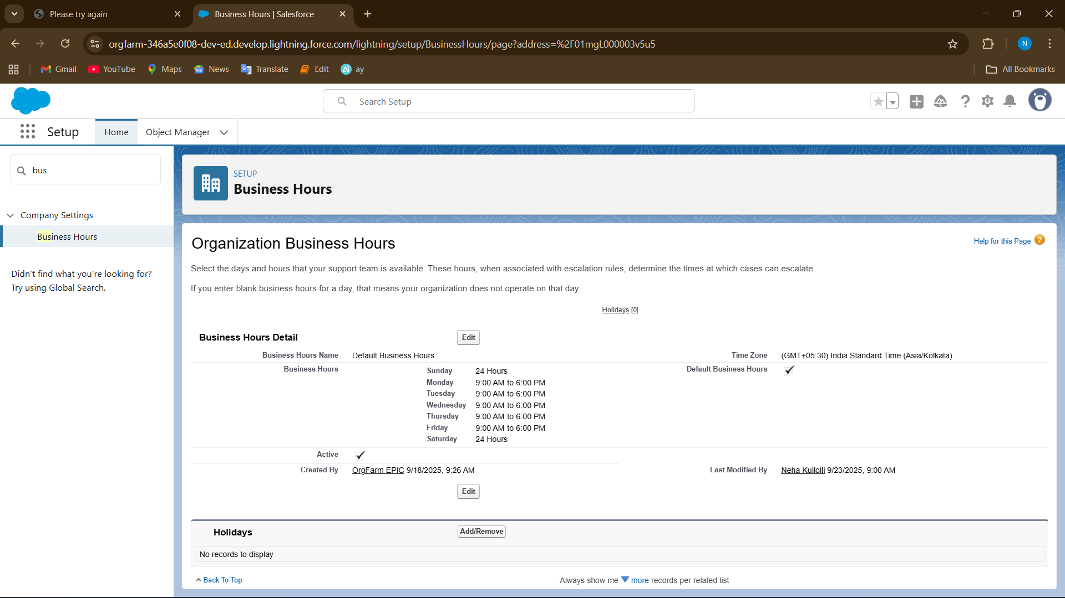

1. Click **⚙️ Gear icon → Setup**.
2. In **Quick Find**, type **Holidays** → click **Holidays** under **Company Settings**.

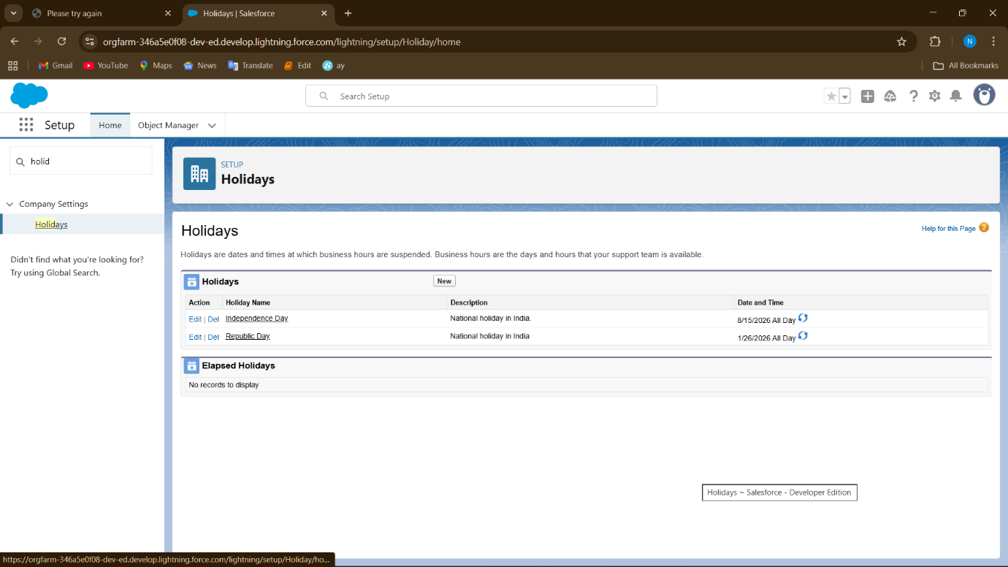

**4. Fiscal Year Settings**

1. Setup → Quick Find → **Fiscal Year** → Open.
2. Use **Standard Fiscal Year** (Jan–Dec).

* No extra setup required for months/quarters.

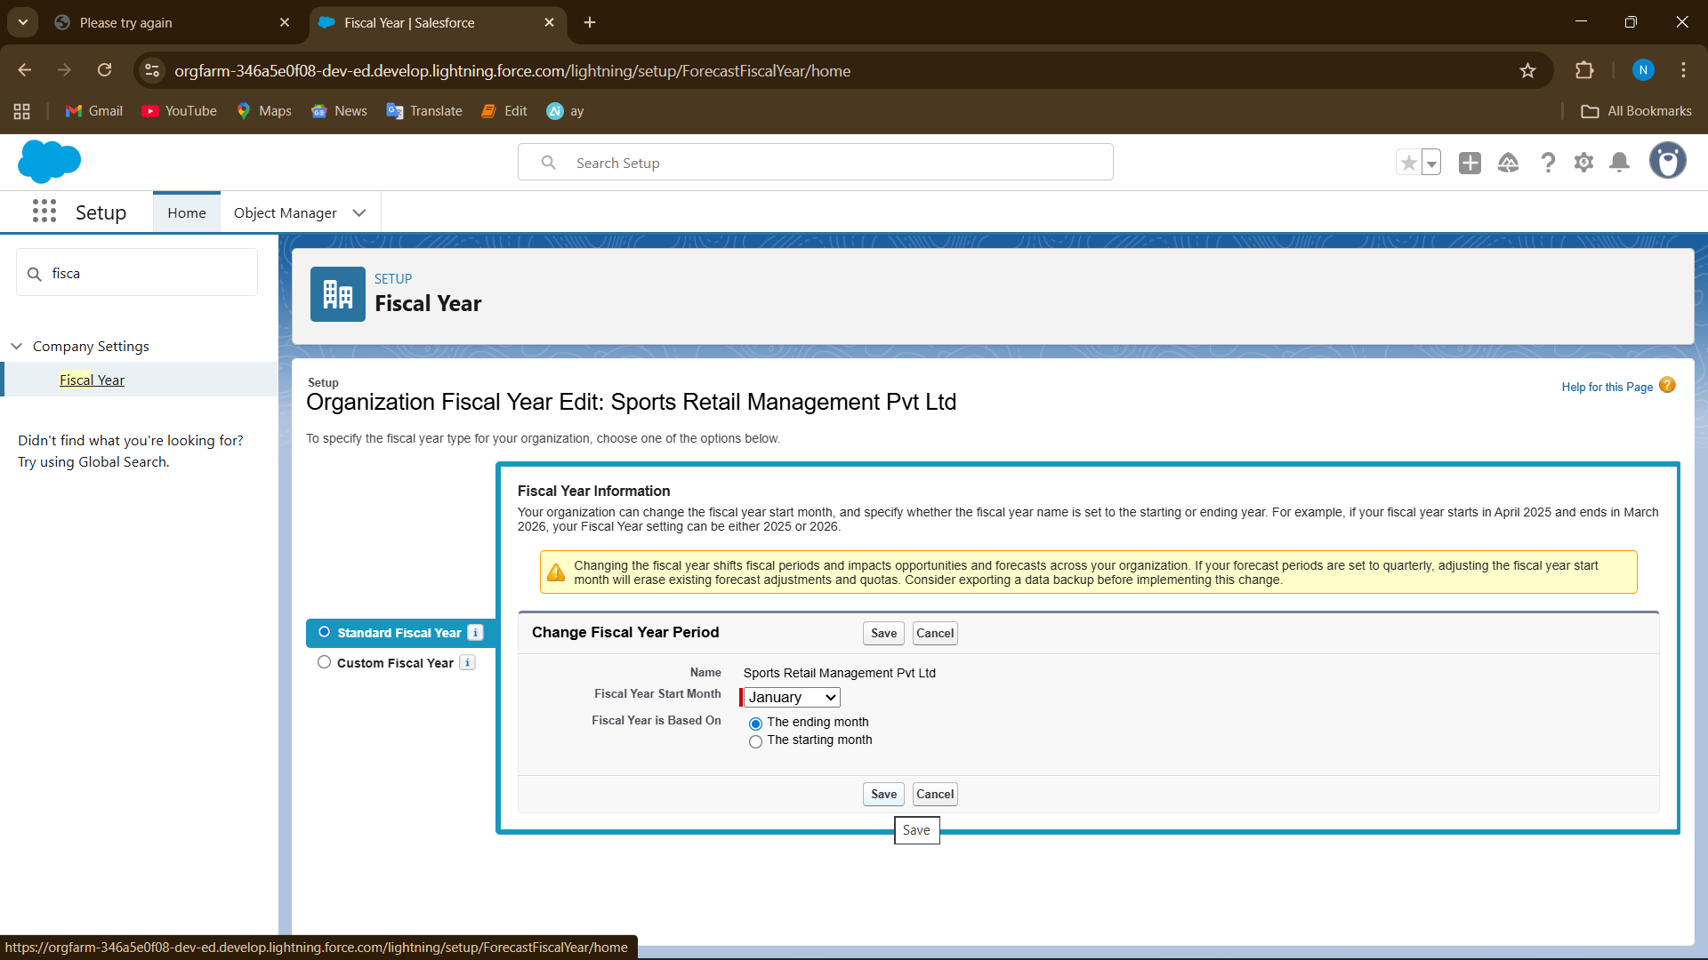

**5. User Setup & Licenses**

**A. Create a New User**

1. Go to **⚙️ Setup**.
2. In **Quick Find**, type **Users** → click **Users**.
3. Click **New User**.
4. Fill in required fields:
   * **First Name / Last Name** → e.g., *Shop* / *Owner*
   * **Email** → shopowner@yourorg.com (must be a valid email format, doesn’t need to be real if for testing)
   * **Username** → must be **unique across Salesforce** (format: email style, e.g., shopowner@yourorg.com.dev)
   * **Alias** → auto-fills (can keep as default)
   * **Nickname** → auto-fills
   * **Role** → choose (Shop Owner / Store Manager, etc.)
   * **User License** → *Salesforce* (default in Developer org)
   * **Profile** → select based on access:
     + *System Administrator* (for Shop Owner)
     + *Sports Admin (Custom)* (for Store Manager)
   * **Active** → ✔ checked
   * (Optional) Check **Generate new password and notify user**.
5. Click **Save**.

**B. Repeat for Each User**

* **Shop Owner** → Profile: System Administrator | Role: Shop Owner
* **Store Manager** → Profile: Sports Admin (Custom) | Role: Store Manager

(Other planned users can be created later: Inventory, Accountant, Sales).

**C. Check User Licenses**

1. Go to **Setup → Company Information**.
2. Scroll down to **User Licenses**.
3. You will see available licenses in Developer Edition, e.g.:
   * Salesforce = 2 full licenses
4. 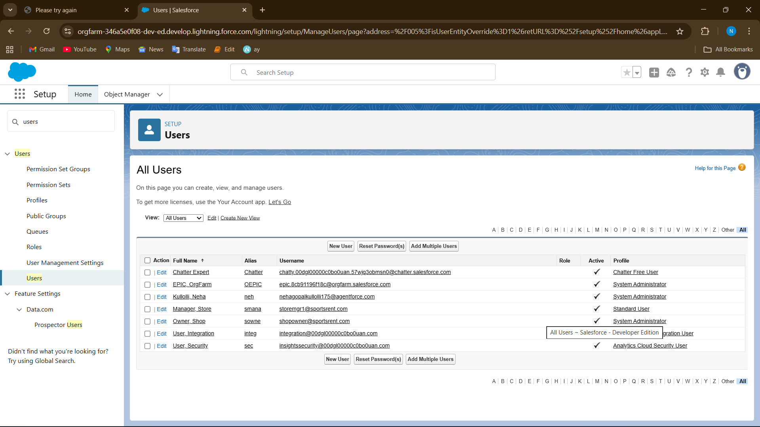

**6. Profiles**

1. Go to **Setup → Quick Find → Profiles → Profiles List**.
2. Find **System Administrator** → Click **Clone**.
3. Enter **Profile Name:** *Sports Admin*
4. **User License:** Salesforce

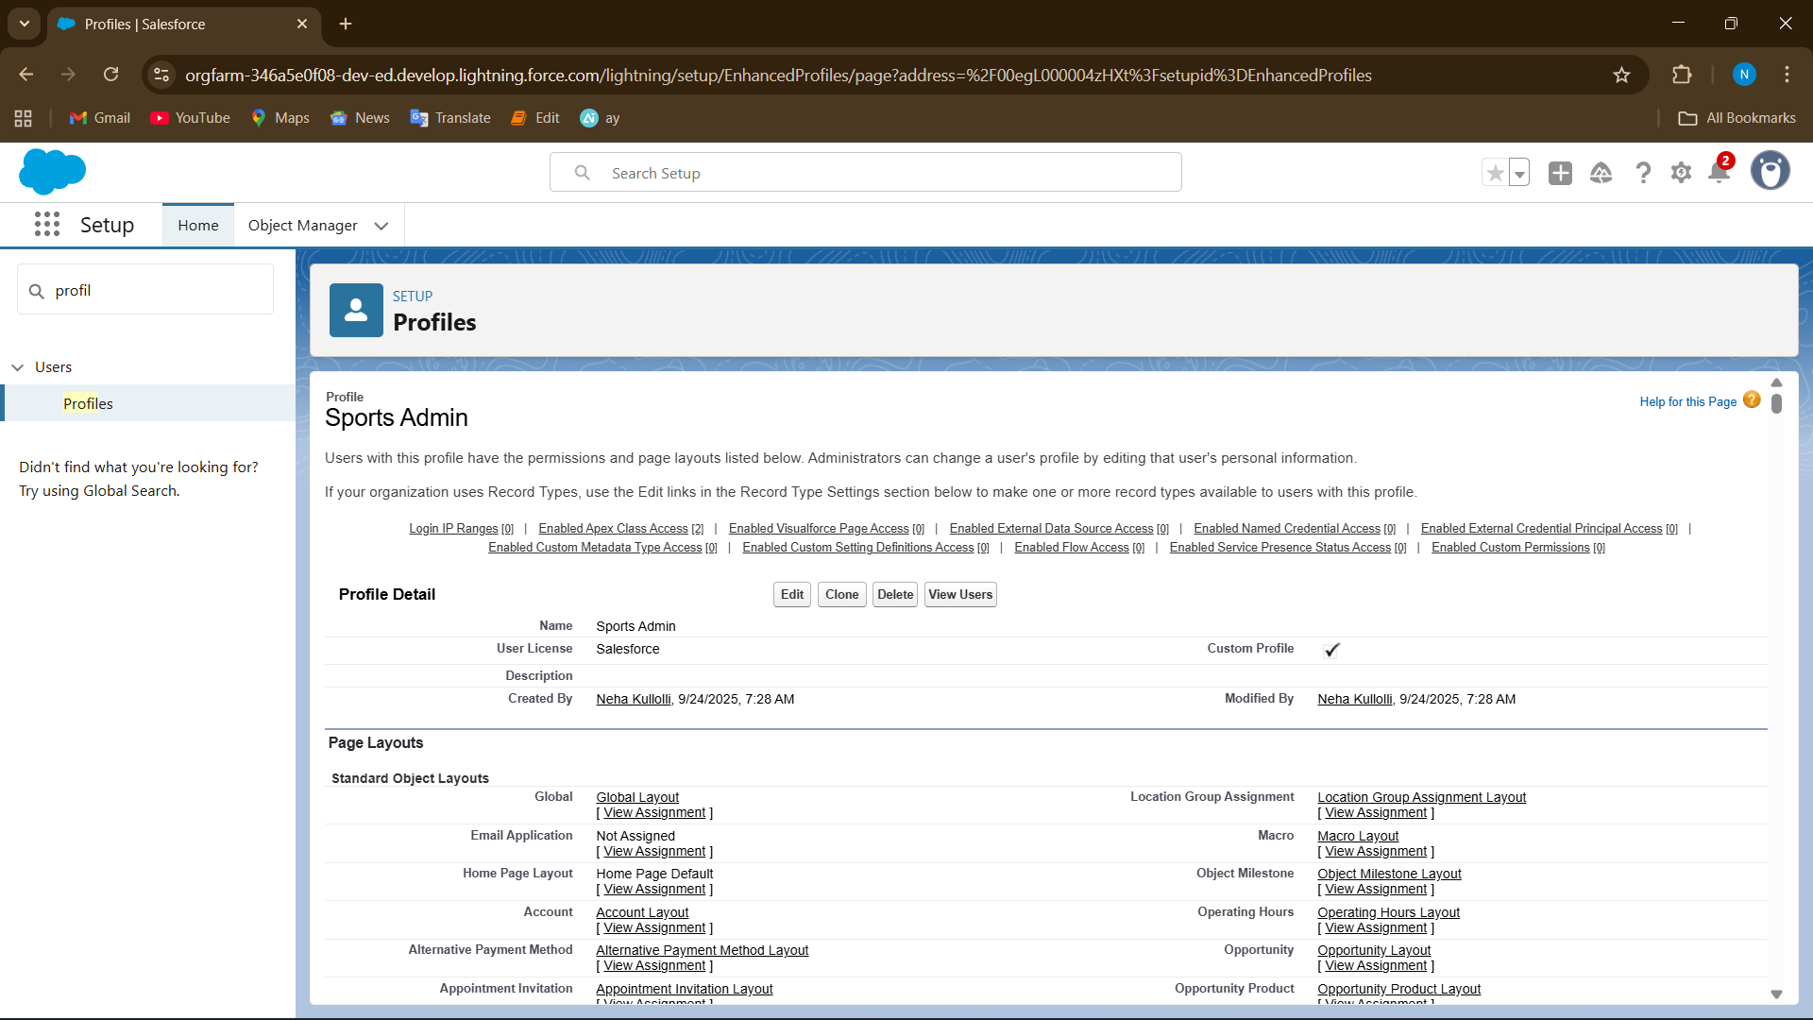

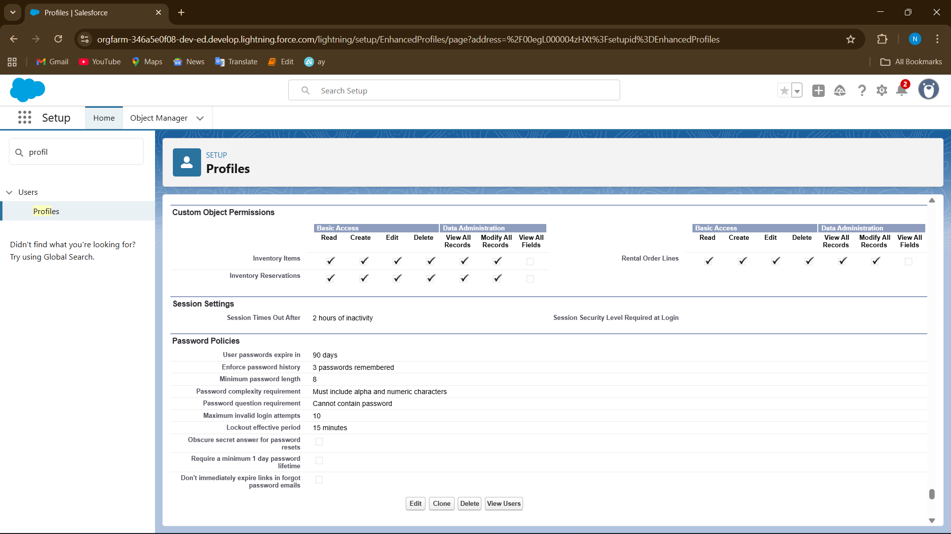

**7. Roles & Role Hierarchy**

● Hierarchy: CRM Admin → Sports Admin → Customer.

● Ensures data visibility flows upwards.

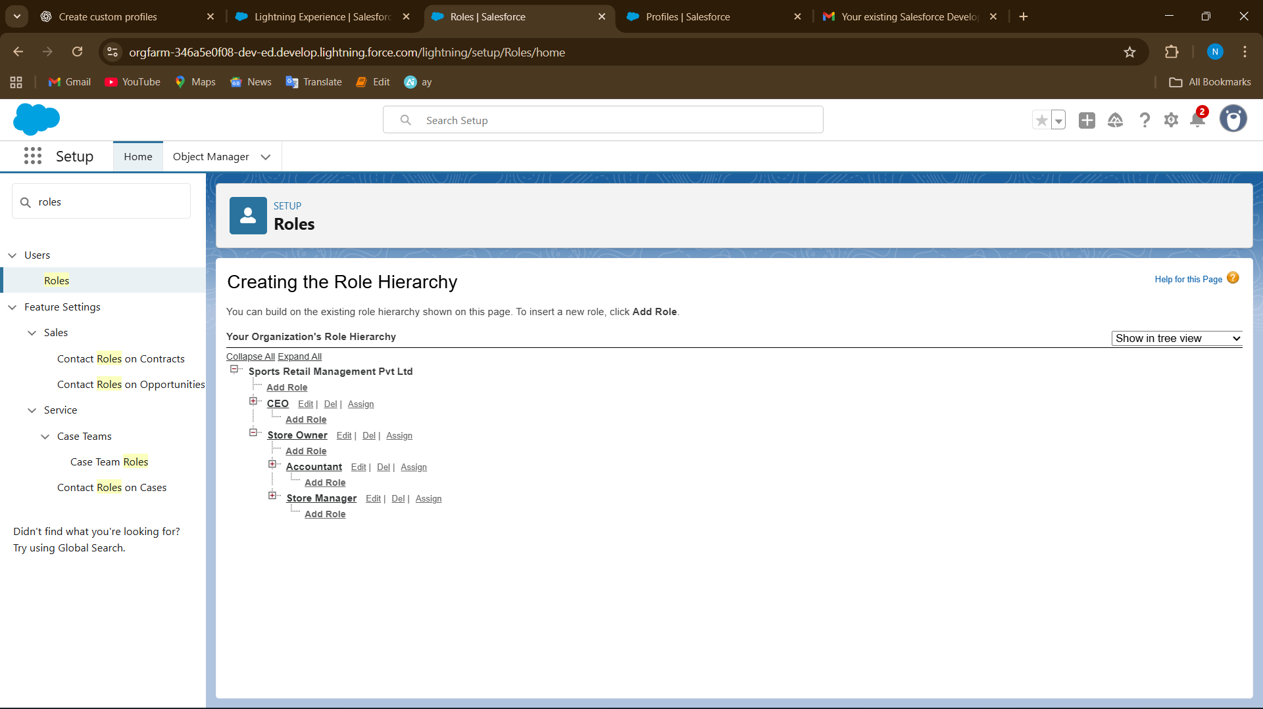

**8. Permission Sets**

1. **Go to Setup → Permission Sets → New**

* Enter **Label** (e.g., Rental Management Access)
* Click **Save**

1. **Add Object Permissions**

* Open the Permission Set → Object Settings → choose object (e.g., Rental) → Edit
* Check **Create, Read, Edit, Delete** → Save

1. **Add System Permissions (if needed)**

* Open Permission Set → System Permissions → Edit
* Check permissions like **Send Email** or **Manage Reports/Dashboards** → Save

1. **Assign Permission Set to Users**

* Permission Set → Manage Assignments → Add Assignments → select user → Assign
* 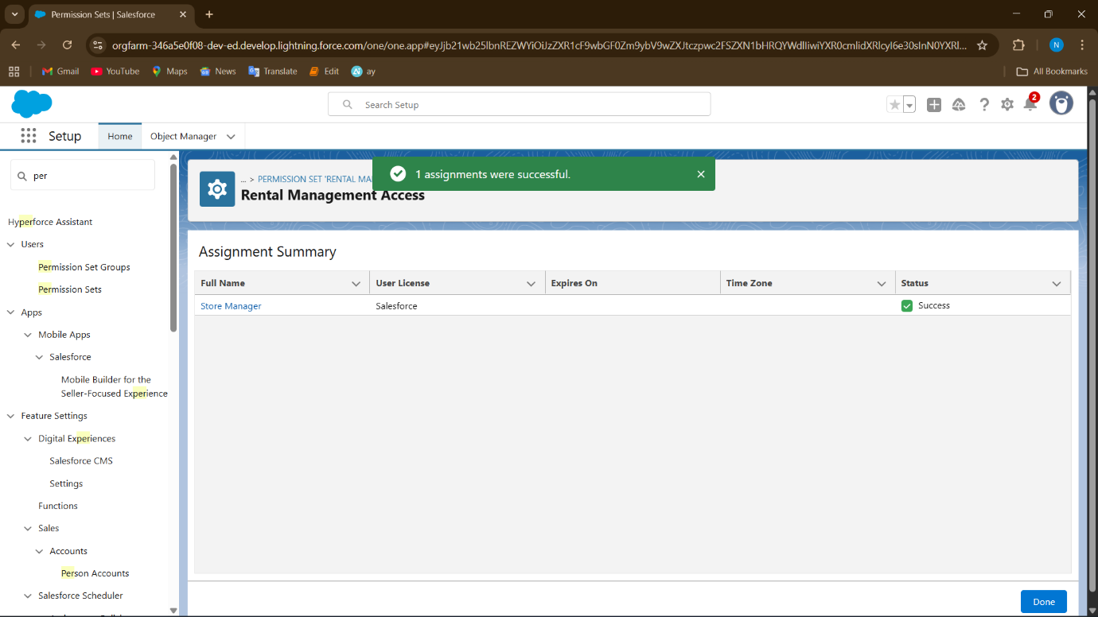

**9. Organization-Wide Defaults (OWD)**

* 1. Quick Find → type **Sharing Settings** → click **Sharing Settings**

**Scroll to Organization-Wide Defaults**

You will see a list of objects (standard & custom)

* 1. **Set Default Access for Each Object**
* **Equipment** → Public Read Only
* **Rentals** → Private
* **Customers** → Private
  1. **Click Save** ✅

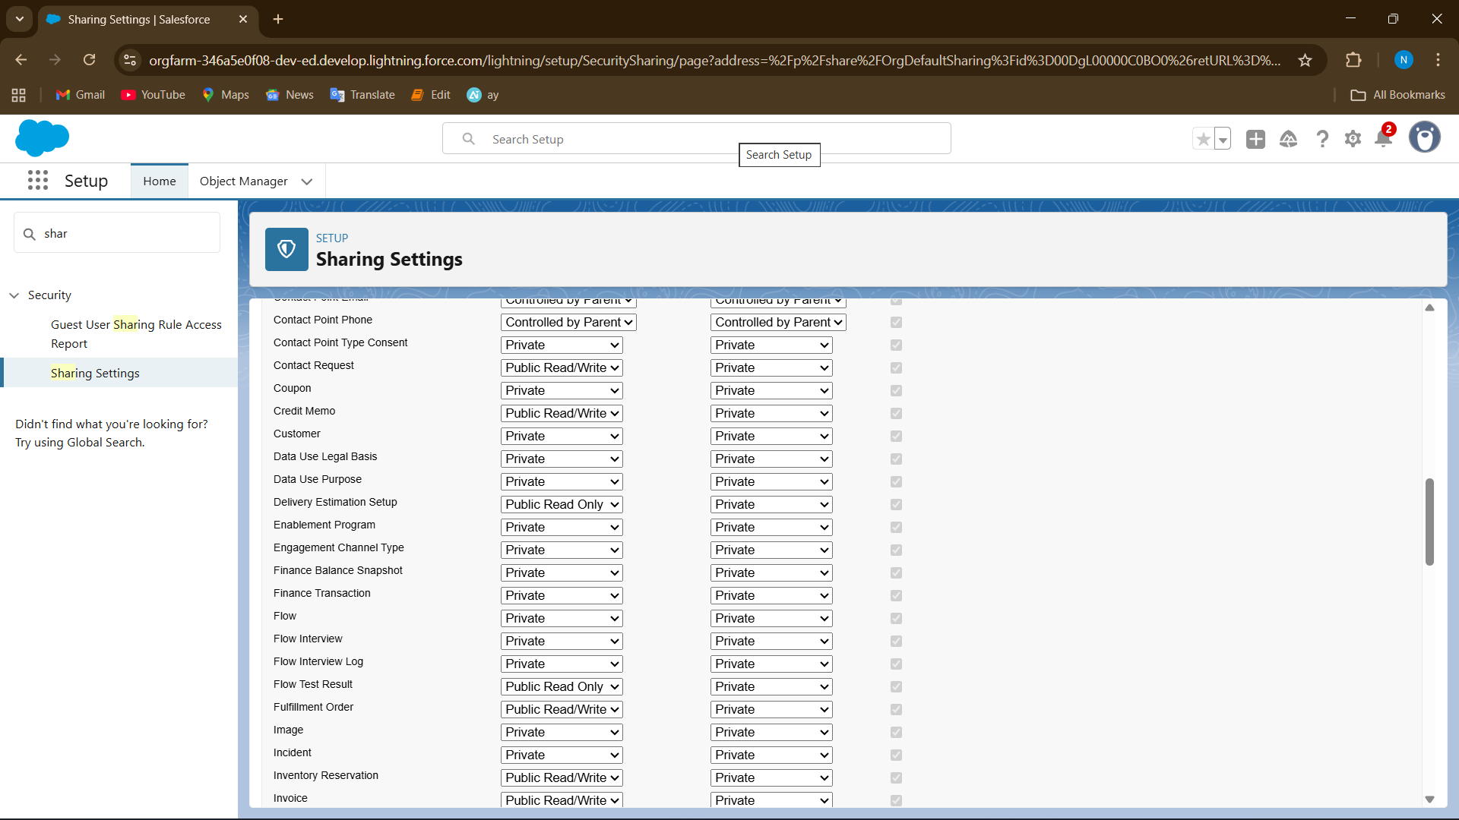

**10. Sharing Rules**

● • **Go to Setup → Security → Sharing Settings**

* Quick Find → type **Sharing Settings** → click **Sharing Settings**

• **Scroll Down to “Sharing Rules” Section**

* Find the object you want to create a sharing rule for (e.g., Rentals)
* Click **New**

• **Choose Rule Type**

* **Based on record owner** → share all records owned by a role or group
* **Based on criteria** → share records that meet certain conditions (e.g., high-value rentals)

• **Set Rule Details**

* **Label:** Give a name (e.g., “Share Rentals with Sports Admin”)
* **Select the users or role** to share with (e.g., Sports Admin role)
* **Access Level:** Read Only or Read/Write

• **Save** ✅

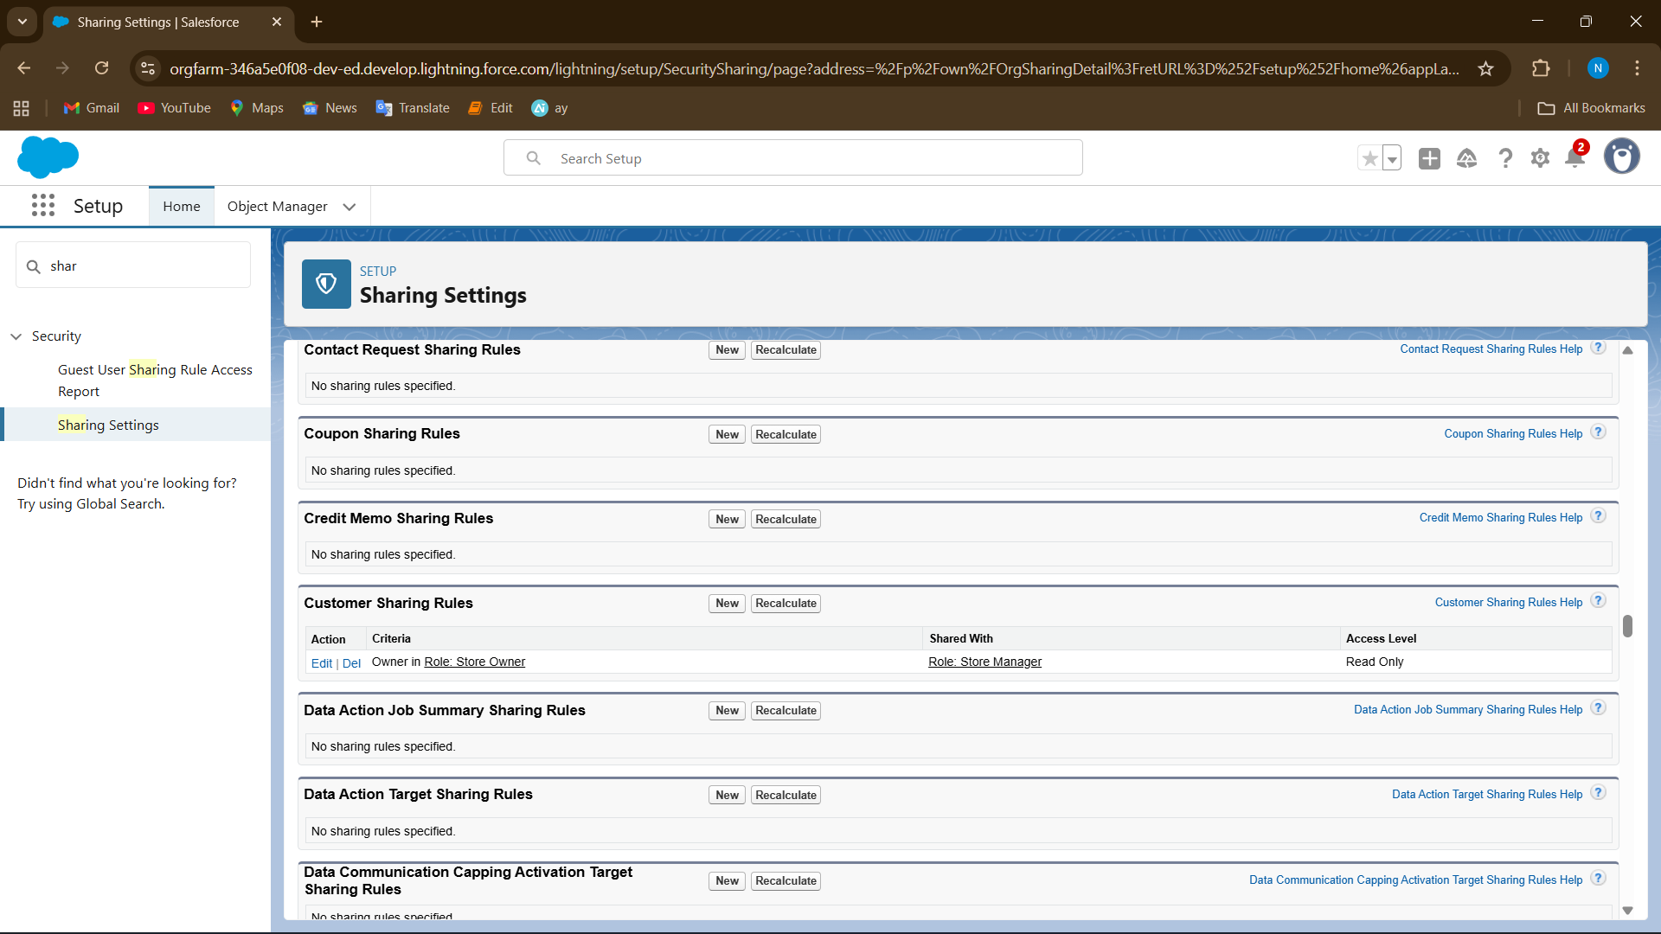

**11. Login Access Policies**

**Admin Login Access**

* **Purpose:** Allow admins to log in as other users to troubleshoot.
* **Steps:**
  1. Setup → Quick Find → **Login Access Policies** → click it
  2. Check **Administrators Can Log in as Any User** ✅
  3. Save

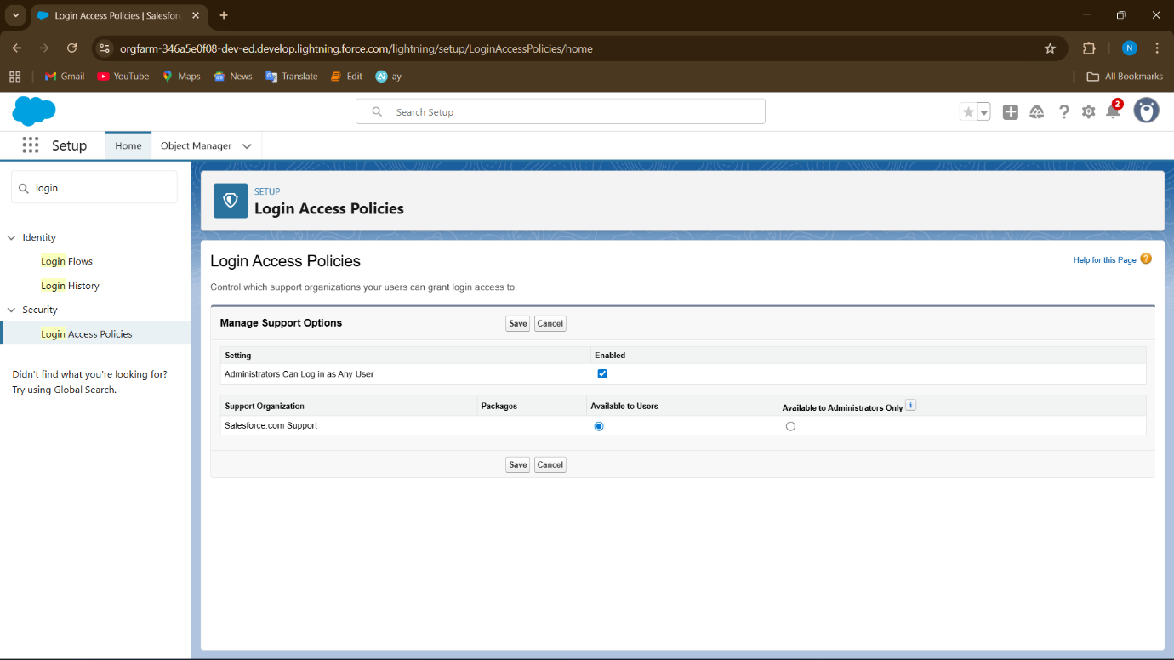

**12. Dev Org Setup**

● **A. Create a Custom App**

1. Setup → Quick Find → **App Manager** → Click **New Lightning App**
2. Enter details:
   * **App Name:** Sports Rental Management
   * **Description (optional):** Manage equipment, rentals, customers, and reports
   * **App Branding (optional):** Choose color/logo
3. Click **Next** → Add navigation items (Tabs)

**B. Add Tabs to the App**

1. Select the objects/tabs you want in this app:
   * **Customers**
   * **Reports**
2. Click **Next → Next → Save**

**C. Assign Profiles to the App**

1. In the last step of the app wizard, choose which **profiles** can access the app:
   * System Administrator → Yes
   * Sports Admin → Yes
   * Customer → Optional (if needed)
2. Save

**D. Verify App**

1. Click **App Launcher (Grid icon)** → Select **Sports Rental Management**
2. Check that **all tabs** appear and are accessible according to profiles